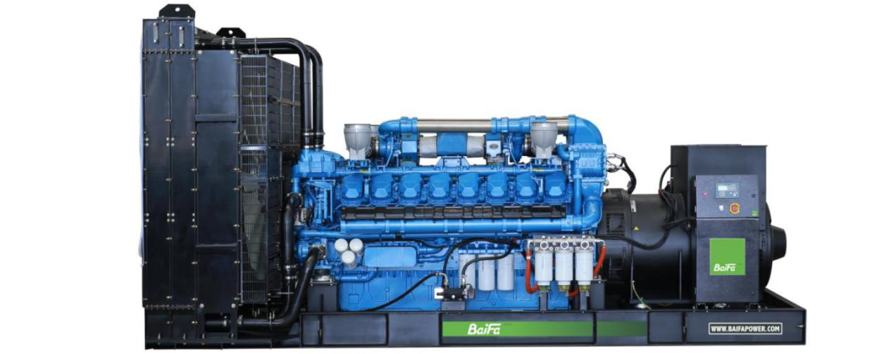

ESP  Standby Power | 1800 kVA | PRP  Prime Power | 1650 kVA
Engine | Baudouin | Alternator | STAMFORD
Engine | 16M33G4D3/5 | Alternator | PI734D1

GENERAL FEATURES
Engine: Baudouin 16M33G4D3/5 | Alternator: single bearing, IP23, insulation class H
40℃ radiator, fans are driven by belt, with safety guard | Dry type air filter, fuel filter & oil filter
Vibration damper | Standard control panel
24V charging alternator | Exhaust bellows, elbows, flange & muffler
Lead-acid batteries, rack and cables | User manual

GENERATOR RATINGS
Voltage | Hz | Phase | PF  （COSΦ） | Standby Amps | Standby Ratings (kW / kVA) | Prime Ratings  (kW / kVA)
440/254 | 50 | 3 | 0.8 | 2362 | 1440kW/1800kVA | 1320kW/1650kVA
415/240 | 50 | 3 | 0.8 | 2504 | 1440kW/1800kVA | 1320kW/1650kVA
400/230 | 50 | 3 | 0.8 | 2598 | 1440kW/1800kVA | 1320kW/1650kVA
380/220 | 50 | 3 | 0.8 | 2735 | 1440kW/1800kVA | 1320kW/1650kVA

Prime Power (PRP): Prime power is available for an unlimited number of annual hours in variable load application, in accordance with GB/T2820（eqv ISO 8528）; A 10% overload capability is available for a period of 1 hour within a 12-hour period of operation.
Standby Power Rating (ESP): The standby power rating is applicable for supplying emergency power for the duration of a utility power interruption. No overload, utility parallel or negotiated outage operation capability is available at this rating.

SALES PROMISES

Baifa Power provides a full line of brand new and high quality products. Each and every unit is strictly factory tested.
Warranty is according to our standard conditions: 15 months from the date BAIFA sold to the first buyer or one year after installation or 1000 running hours (accumulated), whichever comes first.
Service and parts are available from Baifa Power or distributors in your location.

ENGINE SPECIFICATION
Manufacturer / Model | Baudouin 16M33G4D3/5
Air intake system | Turbo, intercooling
Fuel system | High Pressure Common Rail
Cylinder arrangement | 16 cylinders in V
Displacement | 52.3 L
Bore and stroke | 150×185 mm
Compression ratio | 15:1
Rated speed | 1500rpm
Max. Standby power at rated speed | 1680KW
Governor type | ECU

Exhaust System
Exhaust gas flow | 385.5 m³/min
Exhaust temperature | 550℃
Max back pressure | 7.5 kPa
Air Intake System
Max intake restriction | 6.2 kPa
Combustion air flow | 116 m³/min
Air flow required for radiator | 2340 m³/min
Fuel System
Fuel consumption @ 100% (Prime Power) Load | 200.4g/kWh | 341L/h
Fuel consumption @ 75% (Prime Power) Load | 195.6g/kWh | 253L/h
Fuel consumption @ 50% (Prime Power) Load | 201g/kWh | 179L/h

Oil System
Total oil capacity | 175L
Oil consumption ratio based on fuel consumption data | ≤ 0.3 %
Oil sump capacity | 114-171L

Cooling System
Coolant capacity | 542L
Max water temperature | 103℃

ALTERNATOR SPECIFICATION
Industrial alternators meet the requirements of the relevant parts of the BS5000, VDE 0530, NEMA MG1-22, IEC34, CSA 22.2-100 and AS1359.
Alternator Data
Number of Phase | 3
Connecting Type | 3 Phase and 4 Wires, Y type connecting
Number of Bearing | 1
Power Factor | 0.8
Protection Class | IP23
Altitude | ≤1000m
Exciter Type | Brushless exciting
Insulation Class/Temperature Rise | H/H
Telephone Influence Factor (TIF) | ＜50
THF | ＜2%
Alternator Capacity | 1650kVA
Alternator Efficiency | 96.2%

GENERATING SET DATA
Related range of voltage setting | ≥±5%
Steady-state voltage deviation | ≤±1%
Transient voltage deviation (100 % sudden power decrease) | ≤+20%
Transient voltage deviation (sudden power  increase) | ≤-15%
Voltage recovery time (100 % sudden power decrease) | ≤4S
Voltage recovery time (sudden power increase) | ≤4S
Related range of frequency setting | 0-5% adjustable
Steady-state frequency band | ≤0.5%
Transient frequency deviation (100 % sudden power decrease) | ≤+10%
Transient frequency deviation (sudden power increase) | ≤-7%
Frequency recovery time (100 % sudden power decrease) | ≤3S
Frequency recovery time (sudden power increase) | ≤3S

STANDARD FEATURES
Standard auto control system | Exhaust system (including until muffler) | Documents
Oil drain valve | Starting batteries (maintenance-free & watering-free) with connective wires

OPTIONS
Daily fuel tank | Rainproof type | Remote control panel
Alternator heater | Soundproof type | Paralleling system
Spare parts | Trailer type | Switch box
Automatic transfer switch

DIMENSIONS & WEIGHT
Standard Configuration (open type)
Overall Dimensions: 5220×2200×2550 mm
Weight: 12300 kg

Specifications are subject to change without notice.

BAIFA POWER (WUXI) LTD.
Website: www.baifapower.com
Email: marketing@baifapower.com
Tel: +86-510-85342633

